Helping me to live better with Diabetes
An invitation to adults with learning disabilities who have Diabetes, and the people who support them.
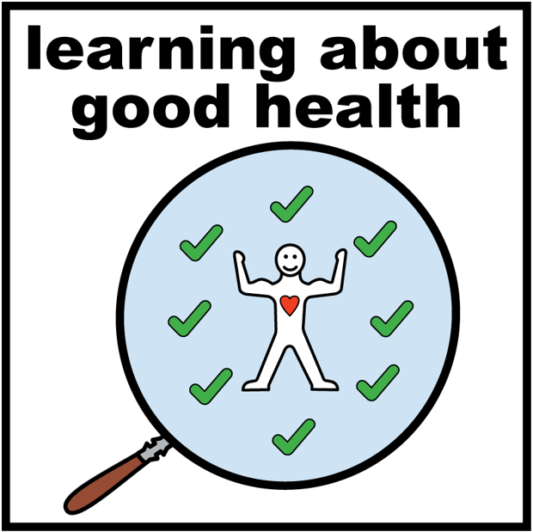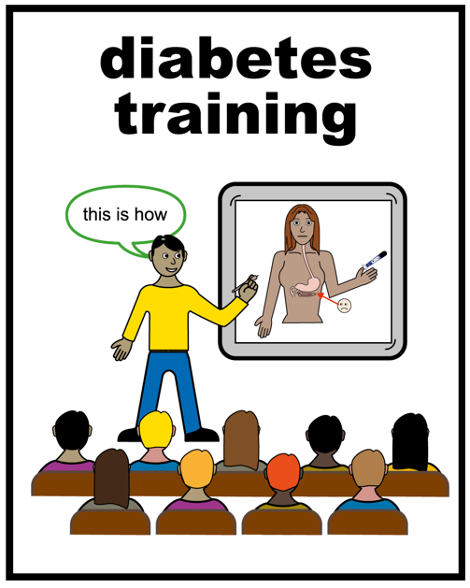 | You are invited to an event to learn more about living well with Diabetes.
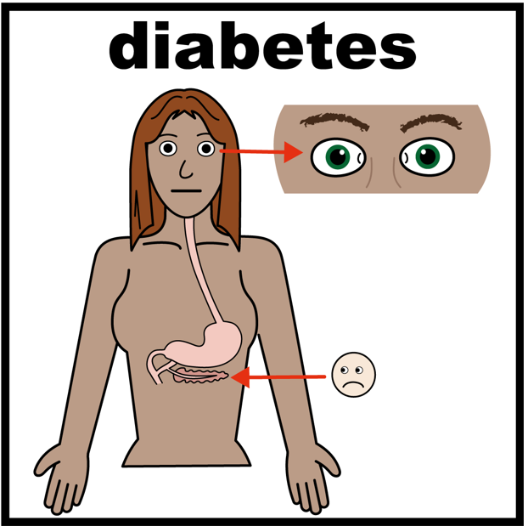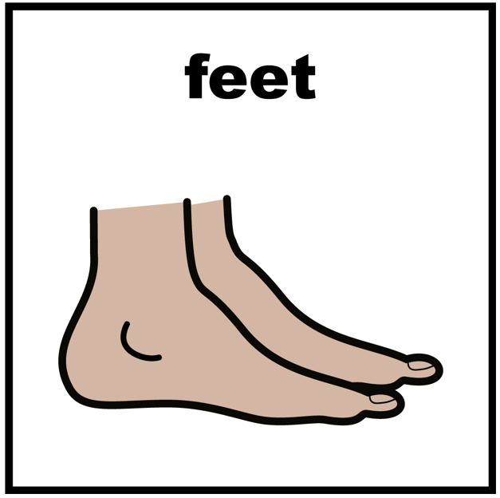 | You will learn about how diabetes affects you and how to take care of yourself including eye care and foot care
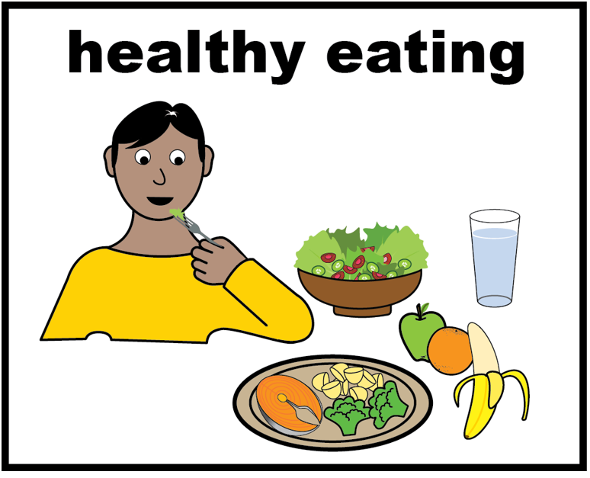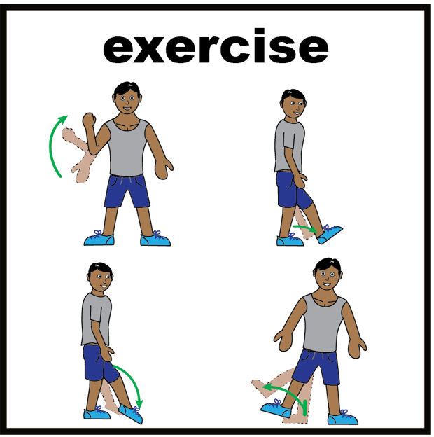 | You will learn about how healthy eating and exercise can help to control your Diabetes
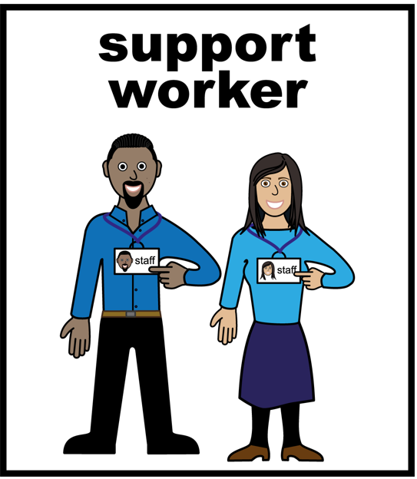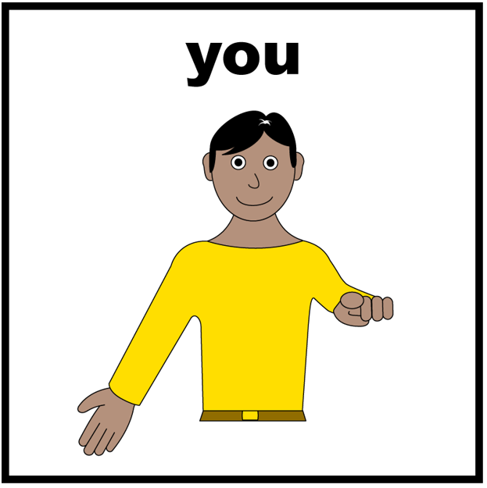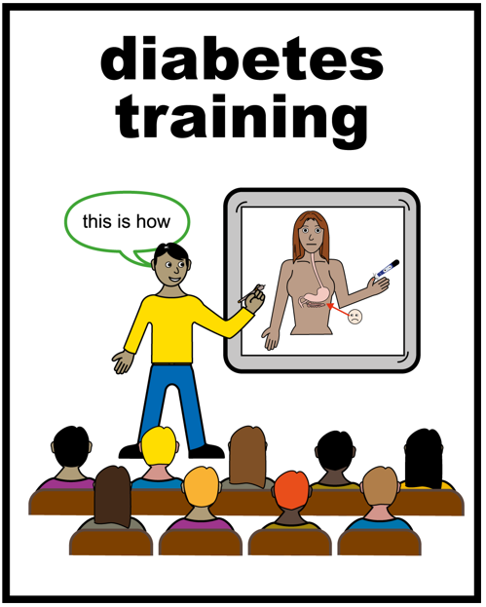 | We think it is a good idea for you to learn together with the person who supports you
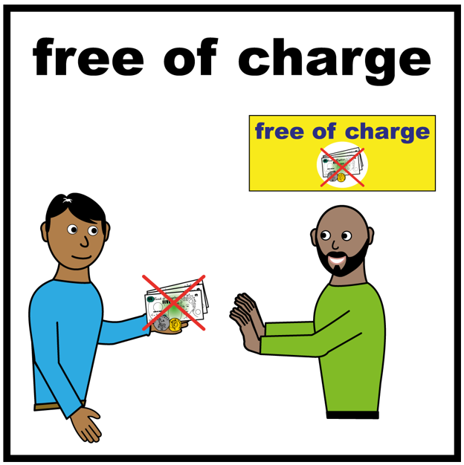 | The event is free for you and your support worker, and we will provide lunch
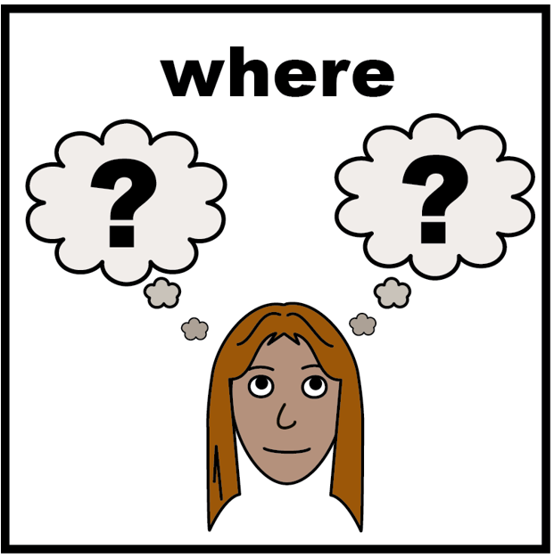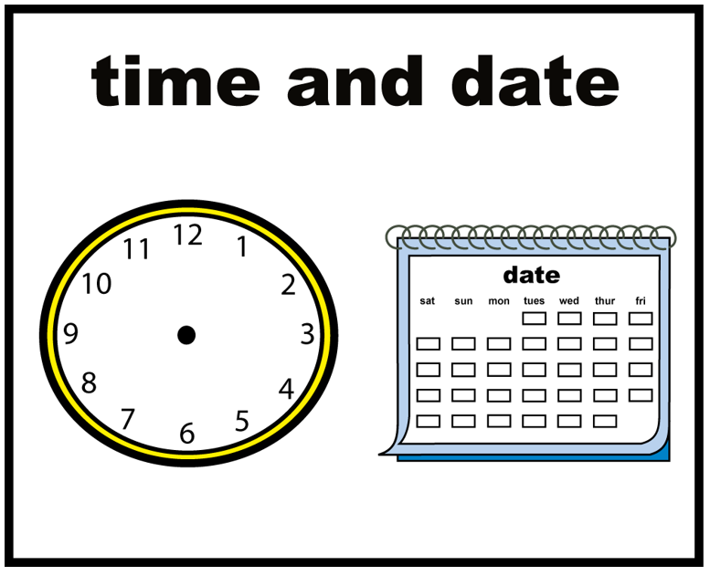 | The event is on 20th July and being held in Brentwood and you would need to be there by 9:30 and stay until 4.30.
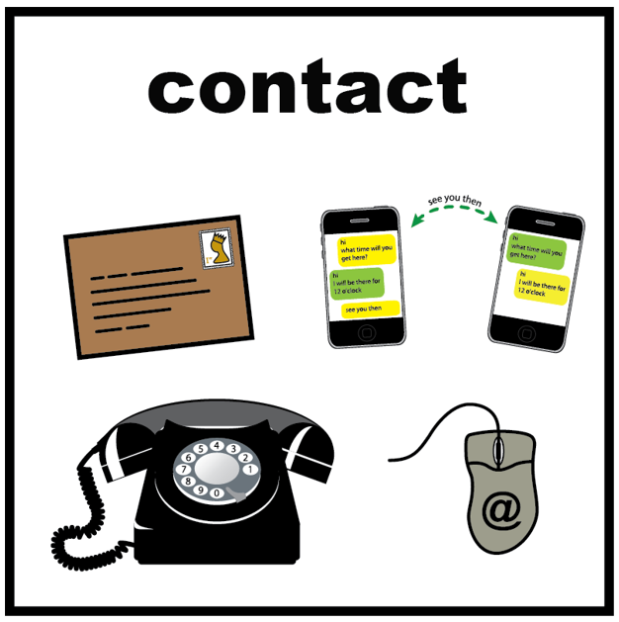 | If you and your support worker are interested, then please get in touch to book places.
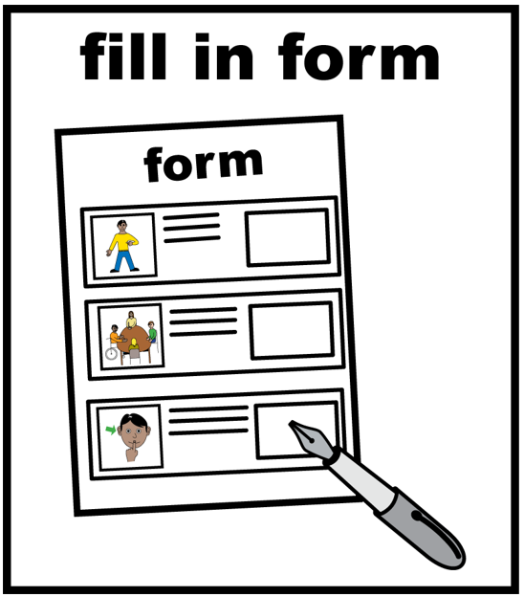 | You can fill in the form below and send it to Jenny Peckham at the email address on the form.

Your name
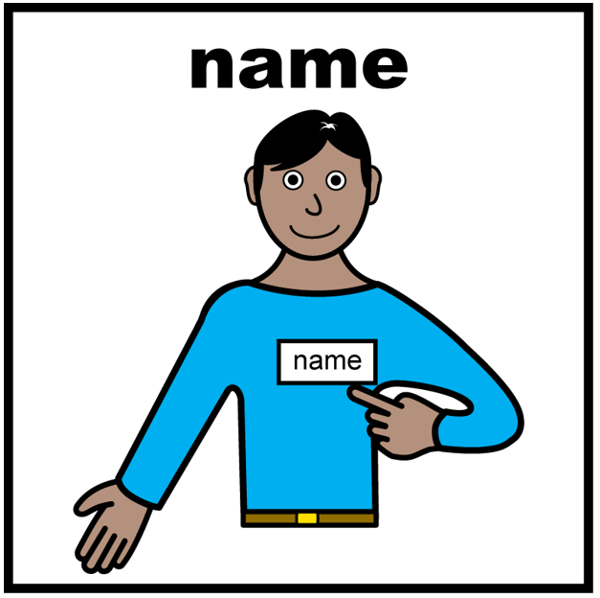
Support workers name
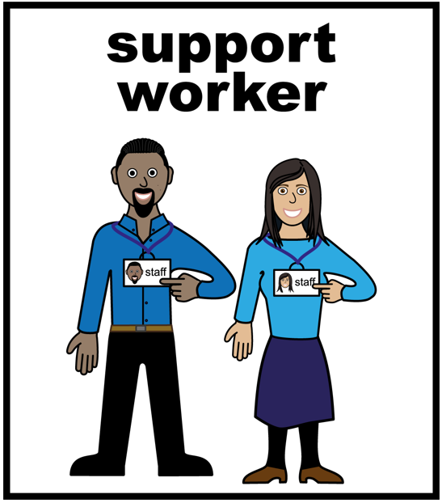
E mail address | We ask for the support workers work e mail address as this is within data protection guidelines
Application form for Diabetes event on 20th July 2022
From 9.30 to 4.30
At: Adult Community College, Bishops Hill, Rayleigh Road, Hutton, Brentwood, CM13 1BD
There is plenty of parking and we will pay for it on the day

Please e- mail this form to jenny.peckham@essex.gov.uk
You and your support worker will get a certificate for attending the event.

